Name: _____________ Zapatista Articles Events Level 2.5

Women’s Revolutionary Law
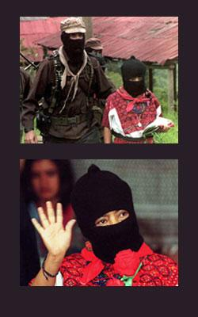
tomraworth.com/notes/?m=200601

The Revolutionary Women’s Law was written by Zapatista women, with Comandante Ramona as one of the key figure involved. At the 1997 First National Congress of Indigenous Women in Oaxaca, Mexico, many women from throughout the nation, especially Chiapas, attended, as well as a Zapatista delegation led by Comandante Ramona. At this congress, women united to share their personal experiences, denounce violence, and propose national and regional changes. Issues discussed at the congress ranged from rape and abuses of the military to indigenous traditions and educational access for women. Affirming the importance of women working together to affect change, at the congress Ramona stated: “We have to unite more, to organize more, to network more…Women lack the courage to speak, to organize, to work. But we women can work with much affection for our pueblos” (Eber 11).
EZLN: The Women's Revolutionary Law

In the just fight for the liberation of our people, the EZLN incorporates women into the revolutionary struggle, regardless of their race, creed, color or political affiliation, requiring only that they share the demands of the exploited people and that they commit to the laws and regulations of the revolution. In addition, taking into account the situation of the woman worker in Mexico, the revolution supports their just demands for equality and justice in the following Women's Revolutionary Law.

First: Women, regardless of their race, creed, color or political affiliation, have the right to participate in the revolutionary struggle in a way determined by their desire and capacity.

Second: Women have the right to work and receive a just salary.

Third: Women have the right to decide the number of children they will have and care for.

Fourth: Women have the right to participate in the affairs of the community and hold positions of authority if they are freely and democratically elected.

Fifth: Women and their children have the right to primary attention in matters of health and nutrition.

Sixth: Women have the right to an education.

Seventh: Women have the right to choose their partner, and are not to be forced into marriage.

Eighth: Women shall not be beaten or physically mistreated by their family members or by strangers. Rape and attempted rape will be severely punished.

Ninth: Women will be able to occupy positions of leadership in the organization and hold military ranks in the revolutionary armed forces.

Tenth: Women will have all the rights and obligations elaborated in the Revolutionary Laws and regulations.
http://almalopez.com/projects/ChicanasLatinas/ramonacomandante3.html

