Three Eras of the India Freedom Struggle – 2.5

Original Title: Gandhi’s Role in Indian Freedom Struggle: A Critical Understanding
Pankaj Borah

Abstract:
Gandhi had an unflinching and unshakable faith in non-violence. He played an important role in India’s struggle for freedom. Indian nationalism achieved its highest peak under Gandhi’s leadership. Gandhi organized the movement on a mass scale. He also tried his best to unite both Hindus and Muslims, and he worked to uplift the economic and social status of the untouchables. Gandhi evolved and developed a powerful non-violent method, which he named Satyagraha.

Introduction:

The Indian Freedom Struggle was one of the largest democratic movements against imperialism and colonialism. The Indian Freedom Struggle provides the best examples of nationalism and patriotism which may be adopted by others in order to root out institutions of colonialism and oppression. Mohandas Karamchand Gandhi, popularly known as ‘Mahatma Gandhi’ was a moral reformist. It is widely accepted that Gandhi was the backbone of the non-violent struggle for freedom of India.

First Era of Gandhi’s Leadership in Indian Freedom Struggle: 1914 – 1919

Gandhi played a pivotal role in India’s struggle for freedom. After twenty years in Africa, Gandhi returned to India in 1914. After his arrival, Gandhi toured his Motherland. He spent four years studying the Indian situation and prepared himself for satyagraha or the application of the soul force based on truth. His goal was the removal of the social and political inequalities from which India suffered. But he was not simply an inactive observer. In 1915, he established, the Satyagraha Ashram near Ahmedabad where a small community of people who accepted his general principles settled.

Gandhi’s Local Experiments:
Champaran Satyagraha: In 1917, Gandhi started satyagraha in the Champaran district to improve the condition of the peasants who cultivated indigo. They were forced to grow indigo in their land. Gandhi and some Congress workers went to Campervan but the British officers ordered to stay out. Gandhi opposed the order and started satyagraha. Gandhi formed a committee to look into the grievances of the peasants. This was Gandhi’s first successful attempt of Civil Disobedience in India.

Supported Mill Workers of Ahmedabad: In 1919 A.D. the textile mill owners reduced the wage of their workers. It resulted in a dispute between the mill owners and the workers. The workers organized a strike. Gandhi went to Ahmedabad, and he personally fasted, or started a hunger strike, to get the workers’ demands accepted. The mill owners ultimately submitted to the workers and increase their wages by 35%.
Kheda Struggle: No sooner was the Ahmedabad mill strike over then a new struggle began a satyagraha. In the Kheda district of Gujrat, a crop failed, and famine conditions threatened the people’s livelihood. Many farmers were unable pay their taxes. Gandhi drafted a petition and asked for the suspension of tax collection. But the Government rejected this.

Gandhi used appeals and petitions but they failed. Gandhi advised the people to withhold their taxes. He also asked the peasants to “fight into death against such a spirit of vindictiveness and tyranny”. Gandhi wanted the peasants to show that “it is impossible to govern men without their consent”. News of the struggle spread all over India. People from different sections of India sent money to help the fight. In response officials confiscated and sold their cattle and property. In some cases government officials destroyed crops.

As time passed and the peasants began to lose confidence. Gandhi felt that something urgent had to be done. He suggested that some farmers remove the crops themselves. He knew this would be followed by arrests. However, most participants were ready to face the consequences. They were arrested and given short-term sentences. Fortunately the struggle ended with a compromise. The Kheda struggle awakened of the masses of India with a sense of their rights and ability to get their demands accepted by the government.

Champaran, Ahmedabad and Kheda served as demonstrations of Gandhi’s style and methods of satyagraha. They also helped him find his feet among the people of India and study their problems up close. As a result of these struggles, Gandhi came to possess a surer understanding of the strengths and weakness of the masses.

Second Era of Gandhi’s Leadership in Indian Freedom Struggle: 1919 - 1930

Agitation against Rowlatt Act: During the World War I, the Defense of India rules were enforced and they gave powers to the government. When the war came to an end in 1919, the government wanted to arm itself with the powers to suppress any revolutionary movement in the country. In 1919, a committee headed by Mr. Justice Rowlatt was appointed to investigate the alarming growth of revolutionary activities and to make a recommendation.

The government passed the Rowlatt Bills, which empowered the government completely. The government could arrest and try political leaders by special courts. It could arrest any person without giving a reason, search any place without a warrant, and imprison anyone without trial. The judges were also empowered to try political cases without a jury. In reality this severely minimized the civil liberties of Indians in the name of curbing terrorist violence. Mahatma Gandhi said, “They are striking demonstration of the civil services to retain its grip on our necks. It considers the bills to be an open challenge to us.”
The Rowlatt Acts was received with great discontent by every section of Indian public opinion. Consequently, a nonviolent movement started.

Mahatma Gandhi declared April 6, 1919 as Satyagraha Day. This was a day of hartals, or strikes, and protests against the Rowlatt Bill. It was a unique success.

Though some incidents of violence occurred. For example, Punjab became dangerous for the government. Gandhi tried to go to Punjab to help and to quiet the people, but the government deported him to Bombay.

JallianwallaBagh Tragedy, April 13, 1919: The most serious disturbance took place at Amritsar. The governor of Punjab, issued a proclamation on April 11, which forbade meetings and processions. April 13th is Baisakhi Day, which is a festival for the beginning of the harvest season and birth of the Khalsa or the foundations of Sikhs. On this day 20,000 people assembled in JallianwallaBagh. The general meeting was peaceful and included a large number of people visiting for the festival.

Brigadier General Dyer used this opportunity to teach the people a lesson for defying the government orders for not assembling. General Dyer arrived at JallianwalaBagh with 500 troops. He ordered them to open fire without giving the people a warning to disperse. About 400 peoples were killed and nearly 1200 were wounded. This event is known as the JallianwalaBagh Massacre or Tragedy. General Dyer hoped that his action would cool down disturbances in the Punjab and India.

The brutality at JallianwalaBagh stunned the entire nation. After the event, Martial Law was imposed in Punjab. For the moment, repression was intensified. For example, police frequently flogged people in the public.

The atmosphere of violence overwhelmed Gandhi, so he stopped the movement on April 18th. This did not mean that Gandhi lost faith either in his non-violent Satyagraha or in the capacity of Indian people to use nonviolence.

A year later, Gandhi launched another nation-wide struggle when Gandhi’s “Indian Experiment” began.

Khilafat Agitation and Gandhi: In addition to the violence atmosphere, a new issue stirred the emotions of Indian Muslims. The problem concerned the Khilafat, or the highest religious office in the Islamic world. After WWI ended, the Allies decided to disband the office of the Caliph (or Khalifat). This enraged the Muslims who considered this an insult to their religious beliefs. The Muslims of India started a powerful politico-religious movement known as Khilafat Movement. Its leaders, the Ali Brothers (Muhammad Ali and Shaukat Ali) plunged themselves heart and soul into the movement. The purpose of the movement was to organize a countrywide agitation if the position of Khalifa ended.

Gandhi viewed the Khilafat movement as a golden opportunity for bringing Muslims and Hindus together on the national front. Gandhi had been interested in Hindu-Muslim unity since his days in South Africa and religious conflict began to increase.

Gandhi contacted the Ali Brothers and felt that their Khilafat demand was just. Gandhi viewed this as a unity of hearts. He said that if he considered Muslims brothers, then “it is my duty to help him in his hour of peril to the best of my ability, if his cause commands itself to me as just.” The Khilafat committee launched a non-cooperation movement on in August 1920 and Gandhi joined. The Congress met in a special session in September 1920 and agreed to participate in the movement.

Non-Cooperation:

The movement officially started August 1, 1920, which was the deadline stated in Gandhi’s letter to the Viceroy. In the letter Gandhi asserted the right of people to “refuse to assist a ruler who misrules.”

The leaders of the Khilafat movement endorsed the non-cooperation movement led by Gandhi. Thus the Khilafat committee and the Congress agreed on the demands. Gandhi’s non-cooperation movement sought to fulfill the following demands:

- The British Government should offer better peace terms to Turkey, and should not touch the “Khalifa” title of the Sultan.
- New reforms should be placed before the Indian people who should attain Swaraj, which is home rule or self rule where Indians govern India.

The people were asked to:

- Refuse to attend government or semi-government functions.
- Gradually withdrawal children from schools and colleges controlled by the government.
- Refuse to serve in the military
- Boycott British court and elections. Boycott foreign goods.
- Surrender all titles and resign from nominated seats in local British political office.
- Establish schools, colleges and private arbitration courts all over India. Develop harmony between Hindus and Muslims and attempt to emancipate women and to remove the untouchablity caste.
- Revive hand weaving and hand spinning and popularize Swadeshi.

The non-cooperation movement was based on nonviolence. Gandhi regarded this as a political program and also as a religious movement. He additionally wanted to clear Indian political life of corruption, terrorism, and fear of the white race.

Home spun cloth become popular and a symbol of freedom. Huge bonfires of foreign cloths were organized all over the country. Volunteers would go from house to house collecting clothes made of foreign cloth, and the entire community would collect to light a bonfire of the goods. Even the visit of the Prince of Wales was boycotted and a complete hartal was observed on November 17, 1921 in Bombay to protest his arrival.

Gandhi made his stand clear by pointing out, “In burning my foreign clothes I burn my shame. . . Our non-cooperation is with the English system, with the material civilization and its attendant greed and exploitation of the weak.” By discarding and burning foreign clothes, Gandhi attempted change the focus away from the hatred and the bitterness caused by British treatment and their ill-will against Indians. He wanted the focus not to be against people or British but against objects.

As a result Gandhi only wore hand-spun clothes. He advised people to spin cloth and weave. The spinning wheel thus became both symbolic and a way for Indians to Gandhi took to be self sufficient. Spinning enabled jobless people to work and also earn a living. With the boycott of foreign cloth and also by making their own cloth Indians gained power. Gandhi worked spinning half an hour a day, and he encouraged others to do the same. This act and his loin cloth became an important symbols in the movement.

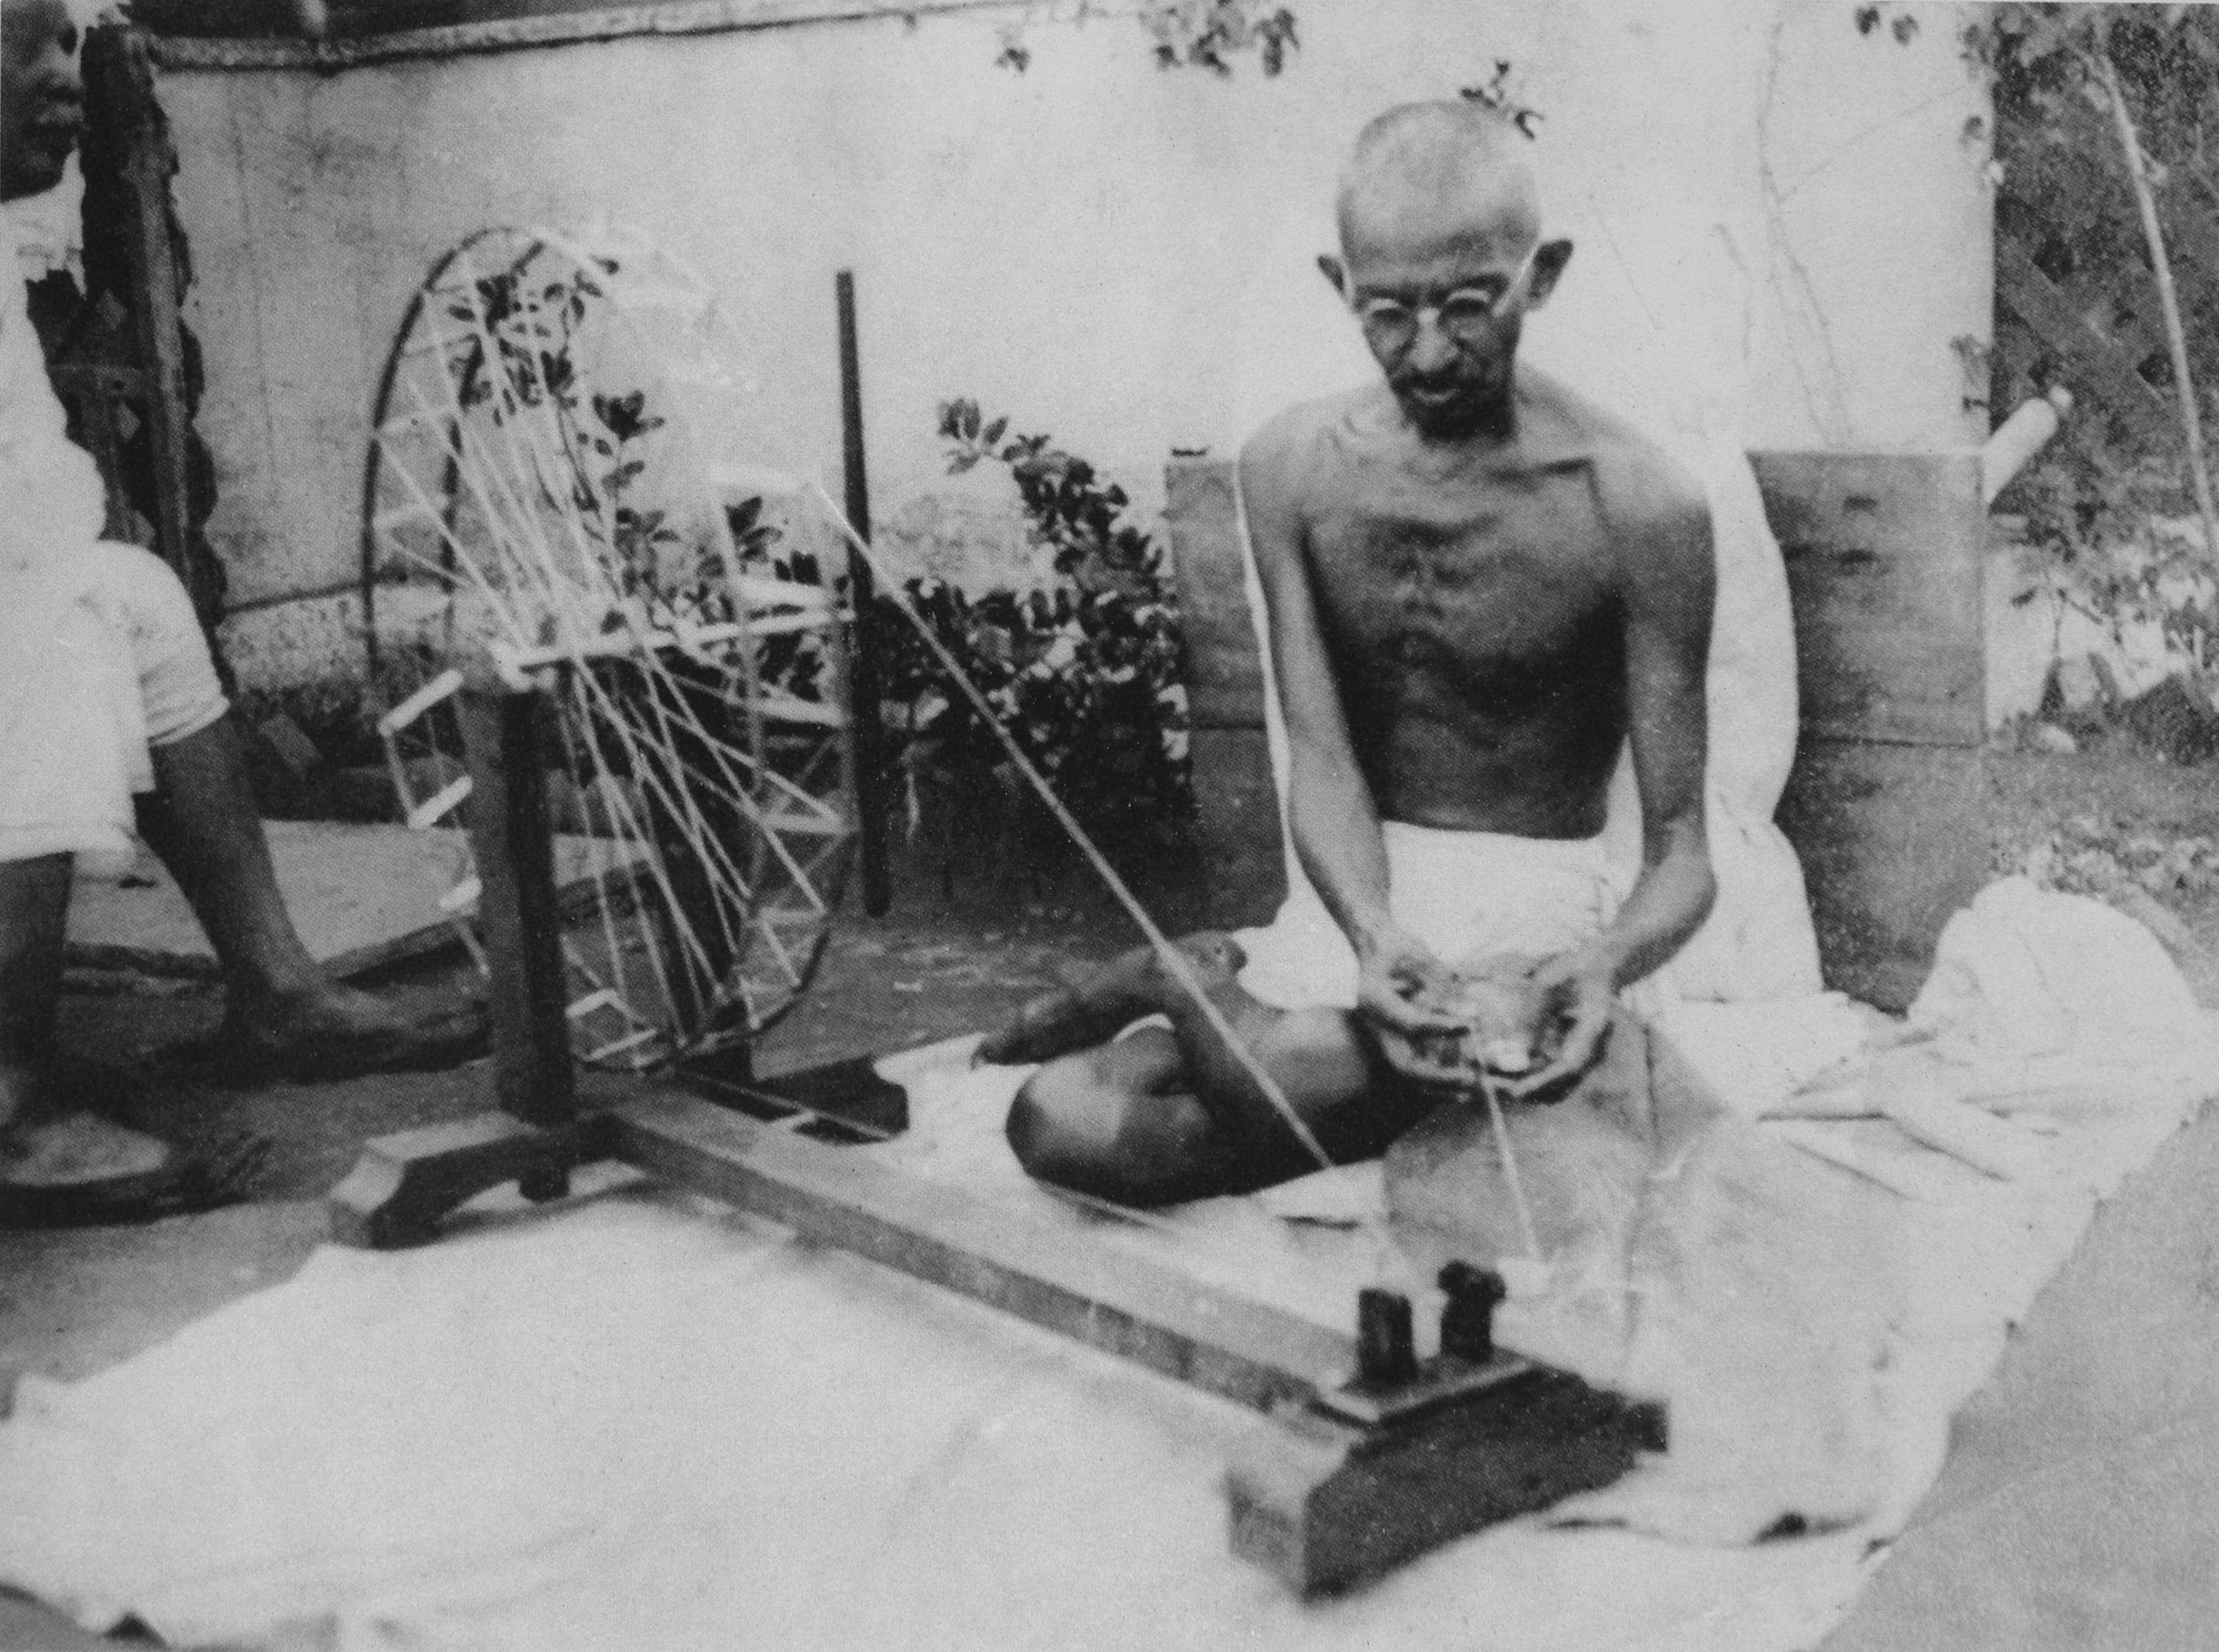
Gandhi spinning at an unknown location in the 1920s.

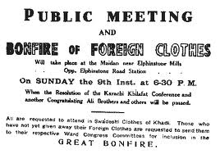

A Poster from the Non-Co-operation Movement

Despite Gandhi’s best effort to keep the noncooperation movement non-violent, the movement became violence at Chauri-Chaura. Again this forced Gandhi to stop the movement.
People could not understand why the whole country had to pay the price for the misbehavior of handful of people who were violent. Many people lost faith on Gandhi’s leadership.

Third Era of Gandhi’s Leadership in Indian Freedom Struggle: 1930 - 1947

The freedom struggle in the 1930s took many steps forward. While the British continued to work without any regard for Indians, Indian political parties stated a common political program. In February 1928, Indian National Congress started a committee that questioned the Constitution. Congress leaders were convinced that the British government would not grant Swaraj, or home rule, meaning self rule, to India till it was forced to do so.
During this session, Congress passed a resolution for complete independence on December 31, 1929, and hoisted a newly adopted a new tricolor flag of independence. On January 26, 1930, the first Independence Day celebrations were held.

The Congress gave the whole country a new hope. A program of civil disobedience, including non-payment of taxes, also began. Members of legislatures were encouraged to resign their seats. In mid-February, 1930, Gandhi launch the Civil Disobedience Movement.

Before the actual launching the campaign, according to the theory of non-violence, Gandhi intended to make a compromise. He gave the British a chance to make changes, and he test their likelihood to relinquish or use power. For this purpose Gandhi forward eleven points that were demands to be fulfilled immediately by the British Government. Gandhi described the points as simple but virtual needs of India.

The eleven points were designed to root out the major evils of structural violence established and practiced by the British. Some of demands included and abolition of the salt tax, the passage of the costal traffic on foreign cloth, a release of all political prisoners, and issue of licenses to use fire arms for self-defense.

The colonial interests and viceroy, Lord Irwin, ignored the eleven points and demands forwarded by Gandhi. With no other alternative, Gandhi launched the Civil Disobedience Movement.

Salt March: The people defied the laws and orders without using violence. Gandhi and 79 of his trusted followers, who were satyahrahis, walked from Ahmedabad to Dandi, a village on the sea coast 200 miles away. The purpose was to disobey the salt laws by picking up lumps of sea salt. Salt is the most necessary article of the common man’s food. The government doubled the tax on the salt and also prevented people from making salt from seawater.

On the morning of April 6, Gandhi violated the salt laws. This signaled the beginning civil disobedience on a mass scale. People all over the country violated laws, produced salt, refused to pay taxes, boycotted of foreign products, engaged in mass strikes and demonstrations. People even burned foreign goods and cloth at public places.

In response and similar to previous events, the government, attempted to crush the movement through ruthless suppression, lathi charges, or beatings, and firing on unarmed crowd of men and women.

Salt Raid: In order to show further non-violent strength in the face of government brutalities Gandhi organize peaceful and non-violent raids of 2500 people on the salt depots. The volunteers walked towards the building. As they advanced the 400 police present beat them with clubs and lathis. Hundreds of blows were inflicted on the demonstrators. The Indians returned not a single blow. Over 260 were injured badly.
They were completely non-violent. After the raid, brave satyagrahis became the source of inspiration not only for the rest of the people of all over India but for people across the world.
First & Second Round Table Conferences: The Congress committee nominated Gandhi to negotiate. During the first Round Table Conference on in February 1931, Gandhi and Lord Irwin talked. The compromise ended with the famous Gandhi-Irwin Pact or the Delhi Pact. The negotiation postponed the Civil Disobedience Movement and released political prisoners.

Gandhi traveled to England in September for the Second Round Table Conference. Gandhi demanded dominion status for India. The British Government refused to accept the basic demand for freedom. The negotiation broke down and Mahatma Gandhi returned to India.

After the failed compromise at the Second Round Table Conference failed to compromise, the British Prime Minister, established a Communal Award. According this plan, Indian Christians and Europeans received separate representation.

Separating representation in politics based on religion and race was a serious problem for Gandhi. To protest, he fasted unto death. The government did not care to save his life or accept his demand. Gandhi’s body deteriorated. The Indian leaders could not avoid to the problems created by the Award. After negotiating, they reached an agreement, called the Poona pact, which reserved seats for each scheduled caste.

Additionally, Congress called the nation to resume the Civil Disobedience Movement. In response, the new governor launched a policy to crush the Congress. The police arrested Gandhi and most all other Congress leaders and the party was declared an illegal group. Police terrorized and committed atrocities on the freedom fighters.
Third Round Table Conference: The British Government held a third Round Table Conference in London in 1932 to solve the constitutional problem of India. No one from the Indian Congress participated.

In 1940 Britain’s position in the Second World War began to worsen. Britain appealed to India to help fight in the war. On June 1st, Gandhi offered the help the government under two conditions. India would fight in the war if
- Britain declared India’s Independence.
- A provisional Government in India was set up with various parties.

Individual Satyagraha
In order to make the British realize that Indians were not willing to cooperate or fight in its war, Gandhi started another Satyagraha. Gandhi believed in non-violence and supported an anti-war movement. However, he did not like to embarrass the British who were engaged in a life and death struggle.

Thus, to register a moral protest against the British, Gandhi thought an individual Satyagraha was the best course of action. According to this new program, men and women of India protested individually against dragging India into the war and the government’s attack on the right of speech. Participants were to disassociate themselves from the war effort publicly and deliberately try to get arrested.

It was not until December 7, 1941 when Japan entered the war against the Allies that the satyagraha movement ended. Since Indian was now in immediate danger, Congress felt a great concern over the safety of India and decided to suspend the individual satyagraha.
Quit India: Congress decided to intensify the struggle to compel the British to accept the Indian demand for independence. The All-India Congress Committee met in August 1942 and planned the Quit India Resolution. The government arrested Gandhi. At the time of his arrest, Gandhi instructed the civil resisters, “Let every non-violent soldiers of freedom write out “Do or Die” on a piece of paper or cloth and stick it on his clothes, so that in case he died in the course of offering Satyagraha, he might be distinguished by that sign.”

Despite the satyagraha movement, violent occurred widespread. People cut telegraph wires, damaged railway lines, and burned of government buildings. The government determined to crush the movement as quickly as possible. Besides typical repressive actions, the government restored to machine guns and aerial firing against Indians. The military took over many towns and cities. The police treated people inhumanly and prisoners were tortured. Police and military firing killed over 10,000 people. After three months, the government crushed the uprising.

Independence: After a long sacrifices committed by national leaders as well as the common masses, India achieved independence on August 15, 1947. Ultimately, India was partitioned into two separate nations: India and Pakistan.

Hindu-Muslim Conflict: Freedom was not without major conflicts and violence. At Gandhi’s prayer meeting on June 4, 1947 he accepted partition because the people wanted it. He said, “the demand has been granted because you asked for it. The Congress never asked for it…But the Congress can feel the pulse of the people.”
Conclusion: Gandhi’s unflinching and unshakable faith in the theory of nonviolence enabled him to devote his life to freeing India from British colonialism. During his entire life, Gandhi preached and practiced the non-violence, not as a policy but as a principle. Nonviolence was the first article of his faith and it was also the last article of his creed. Gandhi evolved and developed a powerful nonviolent method, which he named Satyagraha. For Gandhi Satyagraha was a Non-violent force or Truth-force or Love-force or Moral-force or Spiritual-force and strength to adopt and apply it in every field of life.

Source:
Borah, Pankaj. “Gandhi’s Role in Indian Freedom Struggle: A Critical Understanding” in Global Research Methodology Journal, V0l-II, 7th issue, Nov-Dec-Jan, 2012-13 www.grmgrlaranya.com

