India – Qualities – 2
Humanities 9 – Social Movements

Women in the India Freedom Movement

Source: Manufacturing contraband salt at the beach in Madras
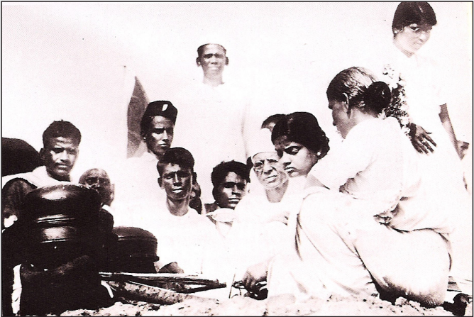
Anil Dharker, The Romance of Salt (New Delhi: Lotus Collection Roli Books, 2005), insert.

Source: Arsenault, Natalie, Christopher Rose, Allegra Azulay, Rachel Meyer. “Women in the Indian Independence Movement: The Salt Protests of 1930,” Restoring Women to World Studies. Hemispheres: The International Outreach Consortium at the University of Texas at Austin. http://www.utexas.edu/cola/orgs/hemispheres/. August 2009.

Women in the Indian Independence Movement: The Salt Protests of 1930

As part of the larger independence movement, Gandhi called for an end to the British monopoly and tax on salt in January 1930. A month later, Gandhi announced he would march to Dandi, a coastal city, to illegally manufacture salt. On the famous Salt March through the villages, Gandhi started with 70 peaceful, non-violent protesters or satyagrahis. These people practiced nonviolence. Along the way, people from villages and towns spontaneously joined the group. When the procession reached Dandi, thousands of people were walking with Gandhi. Among them were many women.

Gandhi included no women in his original group of 70 satyagrahis. He received criticism from many female freedom fighters. Some wrote to him passionately. They urged him to invite women to participate.

On the last day of the march, Sarojini Naidu, Gandhi’s close friend and a nationalist leader in her own right, joined him. Sarojini Naidu was among the most visible leaders (male or female) during this time. She was president of the Indian National Congress and the first woman governor of free India. She was a serious advocate for India. She was also the first woman to be arrested in the salt march.

Naidu’s presence encouraged thousands of other women to join the protest. Some of the women who joined the salt march were wealthy elite women from cities. But the majority were ordinary village women.

After the salt march to Dandi, thousands of women broke the salt law and lead protests all over the country. In fact, it is generally understood that the salt protest was successful precisely because of the many women who made salt, and also sat openly in markets selling and buying it. This time marked a new level of participation by Indian women in the nationalist movement.

The salt march event is generally remembered as the first time masses of Indian women participated in the struggle for independence and marked the involvement of women from all walks of life.

The role of women in the salt protests fits into a larger understanding of the role of women in India’s fight for freedom from British rule. At this time, ideas on women’s participation in the nationalist movement grew out of commonly held cultural beliefs on the nature of Indian women as essentially self-sacrificing and thus ideally suited to non-violent protest. Women emphasized feminine qualities and their role as mothers, specifically as mothers of the nation. Many empowered women found places in the public arena of protest. Women could become agents of change in public spaces.

Source: Interview with Kamaladevi Chattopadhyay, nationalist leader, participant in salt protests and sister-in-law of Sarojini Naidu

Even though only a few women were chosen officially to take part in the salt satyagraha with which the Indian revolution opened on the morning of April 6, 1930, by sunset of that first day it had turned into a mass movement and swept the country.

On that memorable day thousands of women strode down to the sea like proud warriors. But instead of weapons, they bore pitchers of clay, brass and copper; and instead of uniforms, the simple cotton saris of village India.

…Women young and old, rich and poor, came tumbling out in their hundreds and thousands, shaking off the traditional shackles that had held them so long.

Valiantly they went forwards without a trace of fear or embarrassment. They stood at street corners with little packets of salt, crying out: “we have broken the Salt Laws and we are free! Who will buy the salt of freedom?” Their cries never went unheeded. Every passer-by stopped, slipped a coin into their hands and held out proudly a tiny pinch of salt.

Radha Kumar, A History of Doing (New Delhi: Zubaan, 1993), 78.

Source: From a lecture of writer and columnist, Dr. Shakuntala Narasimhan, who describes Kamaladevi Chattopadhyay

When Gandhi announced his satyagraha, Kamaladevi Chattopadhyay was one of the two women (along with Avantikabai Gokhale) chosen for inclusion in the front line unit of seven volunteers at Bombay. The volunteers arrived at the beach, a sea of humanity...and began to boil sea water in small pans to make salt. She made small packets of the salt thus made and sold it to collect money for the satyagraha movement. She went to the share market and auctioned her packets to the highest bidders. She then came up with a cheeky idea. She went inside the (High) court premises and held up a packet of salt and asked a startled magistrate if he would not buy “the salt freedom” and even the freedom movement. That was Kamaladevi; defiant and daring, but always with a touch of cheeky humour. (Unfortunately) there are no records of what the magistrate’s response was.

Shakuntala Narasimhan, “Kamaladevi—The Romantic Rebel,” Vihangama, The Newsletter of the Indira Gandhi National Centre for the Arts, http://www.ignca.nic.in/nl002806.htm.

