Name: _____________________ Zapatistas: Qualities: 1
Comandante Ramona
Comandante Ramona is a female activist. She was born in Mexico in 1959. Ramona worked with Subcomandante Marcos to lead the Zapatista National Liberation Army (EZLN). She was one of the highest ranked leaders in the EZLN.
Ramona led Zapatistas to San Cristobal on New Year’s Day 1994. They demanded rights for the indigenous people. They wanted to end discrimination against the indigenous people. They also wanted them to have land, jobs, housing, food, healthcare and democracy.

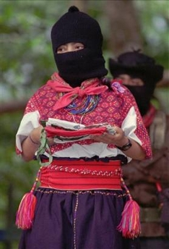
After the protest Ramona met with the Mexican government. In February 1994 she met to discuss making peace. Later she went to Mexico City. In 1996 she helped start the National Indigenous Congress.

Ramona became an important female figure. She was a women’s rights activist before leading the Zapatistas. Ramona helped write the “Revolutionary Law on Women” in 1993. She helped give power to many women. Ramona died in Mexico in 2006. She died of kidney failure. No one knows what her real name was or what she did before becoming a revolutionary.
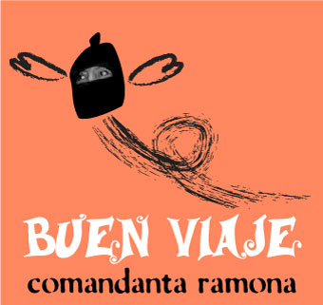
flickr.com/photos/74828596@N00/83655677 this is the photo of Ramona, follow it for 6-7 other awesome “mujeres con dignidad” photos

